Students Name: …………………………………………………………………
School Name:…………………………………… Index Number ……………
P530/3
BIOLOGY
PAPER 3
JULY/AUG, 2023
3 Hours
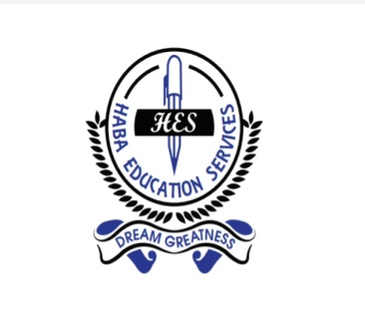

HES INTERNAL MOCK EXAMINATIONS 2023
UGANDA ADVANCED CERTIFICATE OF EDUCATION
BIOLOGY
PAPER 3
3 HOURS

CONFIDENTIAL
This information is given only to facilitate preparation of the examination.
Great care should be taken that the information given below does not reach the candidates either directly or indirectly.

Instructions for preparing specimens and apparatus.

The teacher responsible for preparing specimens must ensure that candidates are provided with correct specimens and other materials as specified in these instructions.

Specimens and solutions which have been assigned codes should be presented to candidates using those codes only and not any other identity.

N.B: The headteacher must ensure that the teacher responsible for preparing the apparatus hands in his / her trial results properly sealed in a separate envelope and firmly fastened (attached) to the candidates’ scripts envelope(s).

Each candidate should be provided with:
- Freshly killed toad / frog, labelled $Q$.
- Medium sized Irish potato, laballed $R$.
- ${75cm}^{3}$ of $1M$ sucrose solution, labeled liquid $N$.
- ${50cm}^{3}$ of water, labeled liquid $M$.
- ${5cm}^{3}$ of 2% amylase solution, labeled $Y$.
- Fresh smooth surface passion fruit, , labelled $U$.
- An orange fruit, labelled $V$.
- An oval shaped half ripe tomato fruit, labelled $S$.
- An avocado fruit, labelled $T$.

Others;

- 8 test tubes.
- Thermometer.
- 2 beakers $(250ml).$
- Microscope.
- Microscope slide.
  - Dissecting kits.
  - Razor blade.
Access to;
  - Reagents used for carrying out food tests.
  - Hot water.
  - Source of heat.

END

